CRUD module README
Project Description
This project is an exercise in developing a CRUD module in Python that creates, reads, updates, and deletes data in a MongoDB database. The module itself logs into the database using given credentials, which are hard coded into the AnimalShelter class then allows the user to Create, Read, Update, and Delete, animals the Austin Animal Control (aac) database.

Motivation
This project is an exercise in creating and manipulating databases using OOP, specifically a NoSQL database using a Python module.
Installation
To get this project running, follow these steps.
- Open Codio module.
- Import Austin Animal Control CSV file into MongoDB and name the database aac.
- Use Admin database to create user credentials with read/write permissions in the database.
- Ensure aac database with user credentials are imported.
- Run MongoDB in your virtual environment.
- Open Jupyter Notebook in Codio.
- Import CRUD_Python_Module.py and ProjectOneTestScript.ipynb
- Run the ProjectOneTestScript.

Requirements
- Python 3
- MongoDB
- PyMongo

PyMongo was chosen to provide a direct interface between Python and MongoDB. CRUD operations are supported natively, and integrate easily with Python

Usage
The AnimalShelter class provides 4 methods to allow a user to Create, Read, Update, and Delete data in the aac animal collection.

CRUD functionality
Create allows the user to insert animal data into the database and return True or False if that data was created.

Read allows the user to query the database using key-value pairs and returns a list of matching documents

Update allows the user to update one or more documents and returns the number of documents updated .

Delete allows the user to delete one or more documents using a query and returns how many documents were deleted

Code Examples
#This method creates new data to import into the database.
def create(self, data):
if data is not None:
self.database.animals.insert_one(data) # data should be dictionary
return True
else:
return False

#This method reads data from the database.
def read(self, query):
if query is not None:
data = self.database.animals.find(query)
return list(data)
else:
return[]

#This method updates data in the database
def update(self, query, updatedInfo):
if query is not None and updatedInfo is not None:
result = self.database.animals.update_many(query, {"$set": updatedInfo})
return result.modified_count
else:
return 0
#This method deletes data from the database
def delete(self, query):
if query is not None:
result = self.database.animals.delete_many(query)
return result.deleted_count
else:
return 0

In the tests, we import our CRUD module and instantiate an instance of our class, we give sample data to import into the database using the create() function with this code, then run a print statement to ensure the data was created.

from CRUD_Python_Module import AnimalShelter

animal = AnimalShelter() #user credentials are hardcoded into the py module.

create_data = {
'age_upon_outcome' : "2 years",
'animal_id' : "D1234",
'animal_type': "Dog",
'breed' : "Pit Bull",
'color' : "Grey",
'date_of_birth' : "unknown",
'datetime': "2026-03-24 02:29pm",
'monthyear':"March, 2026",
'name': "TravisErwinTestDog",
'outcome_subtype': " ",
'outcome_type': "Adoption",
'sex_upon_outcome': "Neutered Male",
'location_lat': "",
'location_long': "",
'age_upon_outcome_in_weeks': 104
}
print("New Animal:", animal.create(create_data))

Next we test the read() function by querying the database using the new animal name as a key, printing out the data of the new animal.

results = animal.read({'name':"TravisErwinTestDog"})

print("Read results:")
for doc in results:
print(doc)

Next we test the update() function by querying an animal by a key value then changing values in the data, then returning the updated animal.
updated_count = animal.update({'name':"TravisErwinTestDog"},
{'age_upon_outcome':"3 years",
'date_of_birth':"July 4, 2023",
'animal_id':"D12345"})

print(updated_count, "files updated.")
print(animal.read({'name':"TravisErwinTestDog"}))

Then we test the delete() function by removing an animal from the collection using a key value and returning the number of animals removed from the collection.
deleted = animal.delete({'name':"TravisErwinTestDog"})

print(deleted, "animal(s) has/have been removed from the collection.")

Screenshots
Image showing successful import of the csv file. 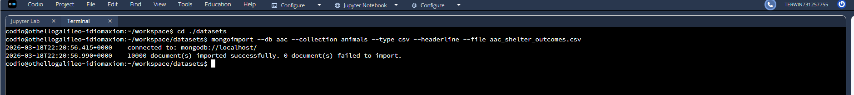

Image showing creation of new user account.
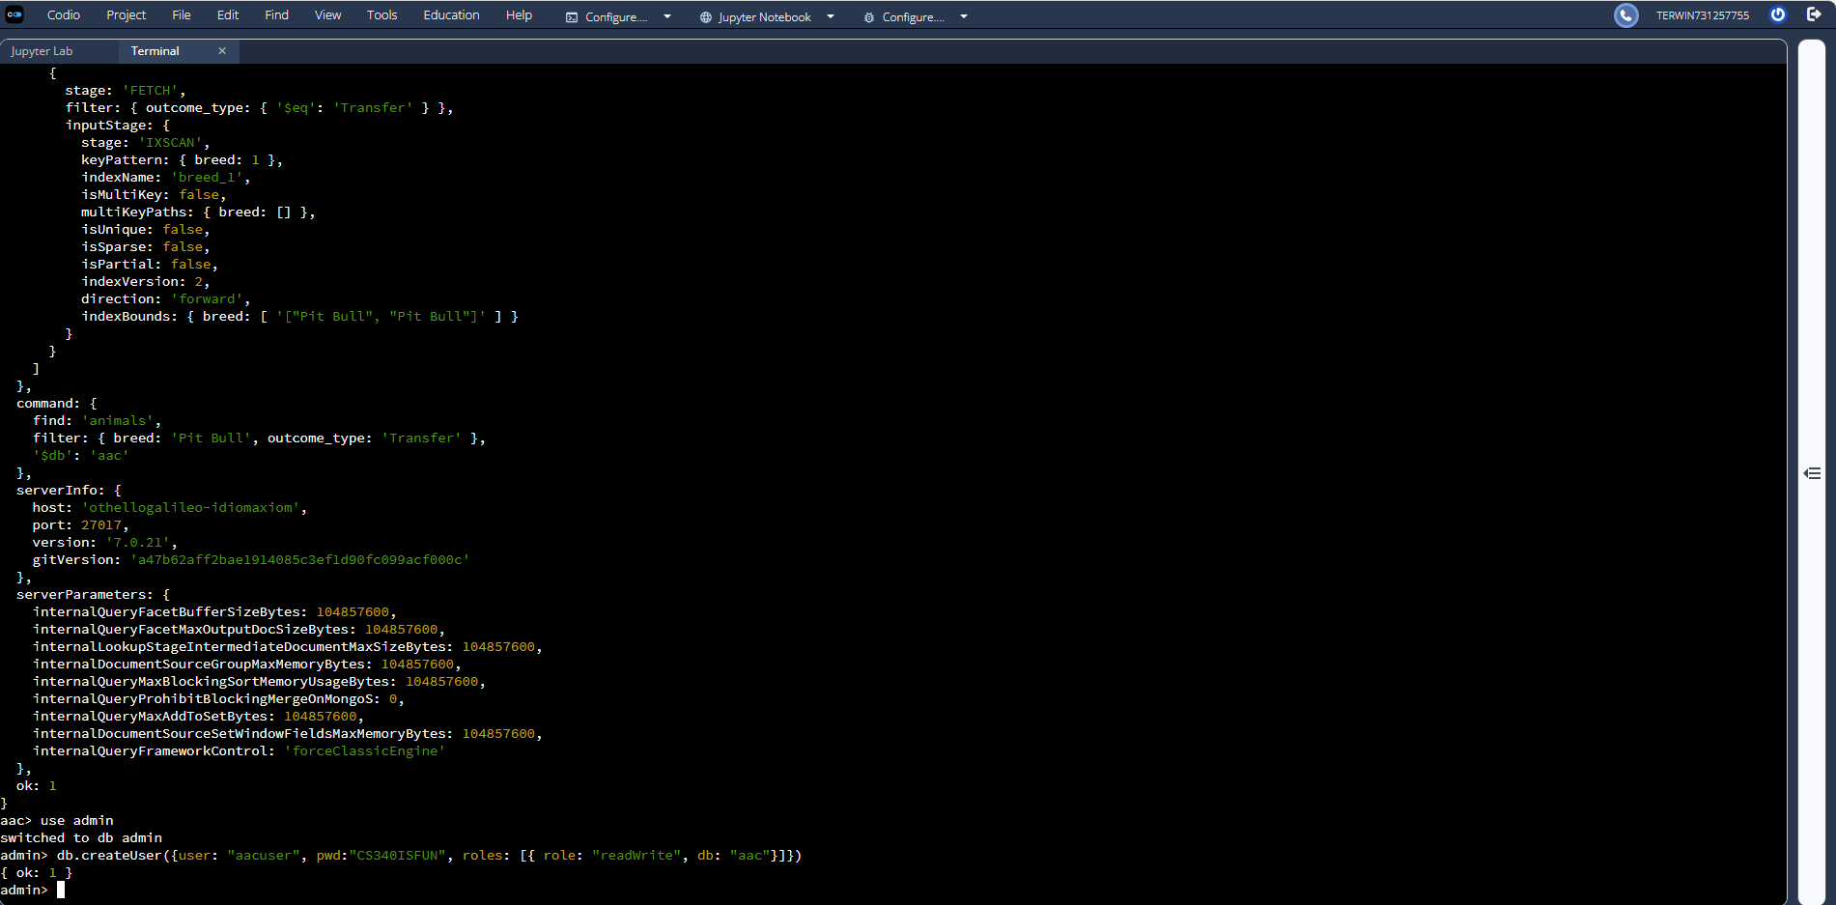
Image showing login was successful and verification of login as specified user. 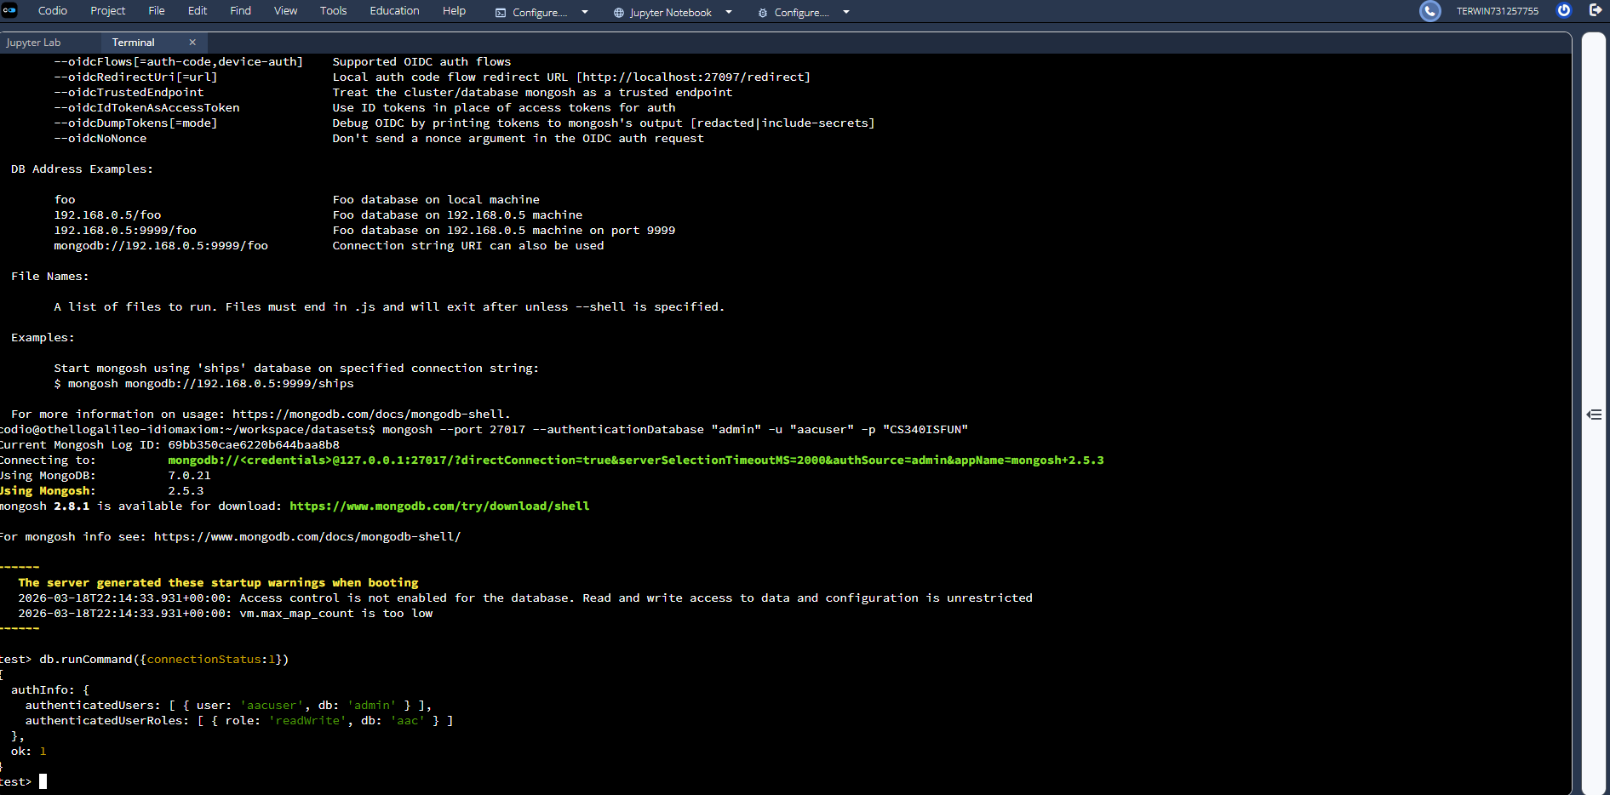

Image showing creation of an animal in the database
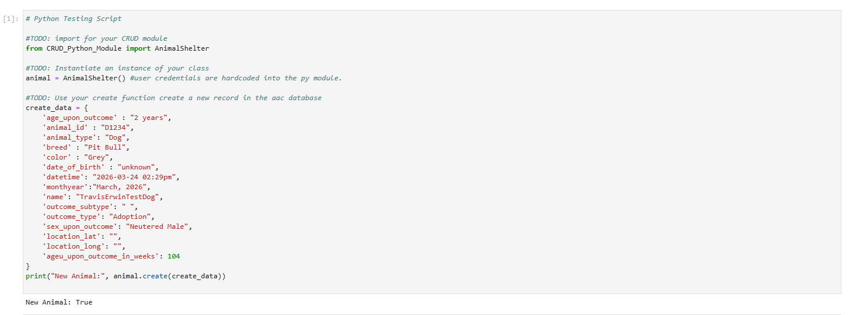
Image showing Read, Update, and Deletion of an animal in the database 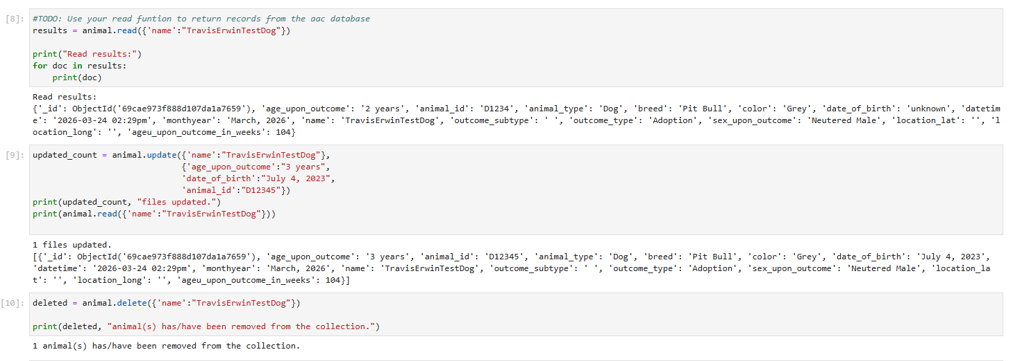

Contact
Travis Erwin
CS-340
March 30, 2026
Travis.Erwin@snhu.edu

